**A MINI PROJECT**

**PYSPARK AND AZURE**

**HOCKEY ANALYSIS PROJECT REPORT**

**DOCUMENTATION BY**

**IYSHWARYA RAMESH**

**RAMITHA R M**

**SANJANA B L**

**TABLE OF CONTENTS**

|  |  |
| --- | --- |
| **S.NO** | **TITLE** |
| **1** | **Introduction** |
| **2** | **Problem Statement**  **2.1 Objective**  **2.2 Abstract of the Project**  **2.3 CSV Files Used** |
| **3** | **Implementation**  **3.1 Work Overview**  **3.2 Project Flow & Data Warehouse Schema**  **3.3 Data Transformation Process** |
| **4** | **Reports + Output CSV Files** |
| **5** | **Conclusion** |

1. **INTRODUCTION**

The purpose of this mini-project is to design, develop, and implement a comprehensive data analysis and reporting system aimed at delivering meaningful insights into hockey game statistics using PySpark. This project focuses on extracting operational data from multiple flat file sources, performing systematic data transformation and cleaning processes, and structuring it into an optimized dimensional data warehouse model following a star schema approach.

Through this framework, the system facilitates in-depth analysis of player and team performances across various leagues, seasons, and match types. By leveraging the power of distributed data processing with PySpark, the project efficiently handles large-scale datasets, performs complex transformations, and generates insightful reports that support strategic decision-making for coaches, analysts, and sports management teams.

The project not only enhances data handling and reporting capabilities but also serves as a practical exercise in applying real-world data engineering techniques using PySpark in a structured ETL (Extract, Transform, Load) pipeline, culminating in the generation of comprehensive reports in CSV format for further visualization and interpretation.

1. **PROBLEM STATEMENT**

**2.1 OBJECTIVE**

To develop an Analysis & Reporting System for Hockey Games using PySpark within an Azure-supported environment. The system aims to manage, analyze, and report operational hockey game data — covering player performance statistics, club records, and match outcomes — by transforming raw operational data from multiple flat files into structured, analytical reports that support effective decision-making.

**2.2 ABSTRACT OF THE PROJECT**

This project involves building an end-to-end data processing and reporting pipeline using PySpark to handle diverse operational hockey data, including player profiles, team performances, league records, and match results. The raw data, collected from heterogeneous flat file sources, undergoes a systematic Extract, Load, and Transform (ELT) process to convert it into a well-defined dimensional data warehouse model.

A star schema is designed, comprising various dimension tables (such as Player, Club, Country, League, Match Type, and Time) and fact tables for capturing key performance metrics. The transformed data is then used to generate a set of insightful, business-relevant reports, including top goal scorers, maximum appearances, disciplinary records, and club performance rankings.

The system facilitates efficient, scalable processing of large datasets and demonstrates practical application of PySpark’s distributed computing capabilities in building a real-time sports analytics reporting solution.

* 1. **CSV FILES USED**







**3.IMPLEMENTATION**

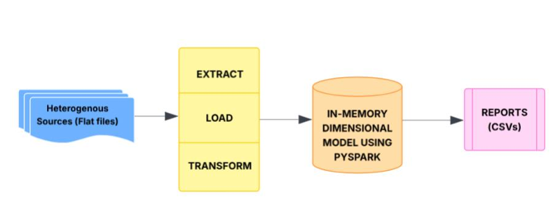

**3.1 WORK OVERVIEW:**

1. Data Collection & Loading

2. Data Cleaning & Preprocessing

3. Data Analysis

4. Reporting & Visualization

5. Final Summary

**The source files are:**

**SOURCE FILE 1: PLAYER STATISTICS**

* Year
* Match
* Player Name
* Club Name
* Country Name
* Appearances, Goals scored, Goals assist, Shots, Fouls, Cards, Salary, etc.

**SOURCE FILE 2: TEAM STATISTICS**

* Year
* Match Name
* League Name
* Club Name
* Country Name
* Appearances, Wins, Losses, Drawn, Clean Sheets, Net Worth
* Date Dimension.

**3.2 PROJECT FLOW & DATA WAREHOUSE SCHEMA**

**PROJECT WORKFLOW:**

* Operational data from heterogeneous sources (CSV files)
* Extraction, Loading, and Transformation using PySpark
* In-memory dimensional model creation
* Report generation in CSV format

**DATA WAREHOUSE MODEL:**

**DIMENSION TABLES**

* **League:**

League_ID

League_Name.

* **Club:**

Club_ID

Club_Name

League_ID

Manager

Owner

* **Country:**

Country_ID

Country_Name

Coach

* **Match Type:**

Match_Type_ID

Match_Name

* **Player:**

Player_ID

Player_Name

Club_ID

Country_ID

Position

Jersey No

DOB

Nationality

* **Time:**

Time_ID

Year

Quarter

Month

**FACT TABLES**

**Fact_Player_Statistics:**

* Fact_ID
* Time_ID
* Match_Type_ID
* Player_ID
* Club_ID
* Appearances
* Goals
* Shots
* Fouls
* Salary, etc.

**Fact_Team_Statistics:**

* Fact_ID
* Time_ID
* League_ID
* Club_ID
* Wins
* Losses
* Drawn
* Clean Sheets
* Net Worth, etc.

**3.3 DATA TRANSFORMATION PROCESS**

**STEPS:**

* Load source CSV files into PySpark DataFrames
* Clean and preprocess the data (null handling, trimming, datatype conversion)
* Create unique IDs for each dimension table using ranking functions
* Populate Dimension tables first
* Generate Fact tables by joining respective dimension IDs
* Create analytical queries to produce the required reports
* Export reports as CSV files

**STEPS PERFORMED:**

**STEP 1: AZURE RESOURCE SETUP**

• Create Azure Storage Account

• Create Containers

**STEP 2: UPLOAD FILES TO BLOB STORAGE**

**STEP 3: INGEST SOURCE FILES USING AZURE DATA FACTORY**

(ADF)

• Create Azure Data factory

• Open ADF Studio

• Create Linked services

• Create datasets

• Create a pipeline to copy data

• Run the pipeline

**STEP 4: CREATE AZURE SQL DATABASE**

• Create SQL Database on Azure

• Configure firewall

• Connect to SQL database

• Create table structure

**STEP 5: REGISTERED AN APP MOUNTED THE AZURE DATA LAKE**

**STORAGE (ADLS) CONTAINER TO AZURE DATABRICKS**

**STEP 6: CREATE AZURE DATABRICKS WORKSPACE**

**STEP 7: TRANFORMATION IN DATABRICKS**

• Read CSVs

• Create dimensions

• Create fact tables

• Write transformed tables to output

**STEP 8: LOAD TO SQL USING AZURE DATA FCATORY (ADF)**

• Create linked services

• Create datasets (Input + Output)

• Build the copy data pipeline

• Run the pipeline

• Verify in Azure SQL

**STEP 9: SQL REPORTING QUERIES**

**STEP 10: CSV OUTPUT**

**SCREEN SHOTS:**

**PHASE 1:**

**CREATE AZURE RESOURCE SETUP**

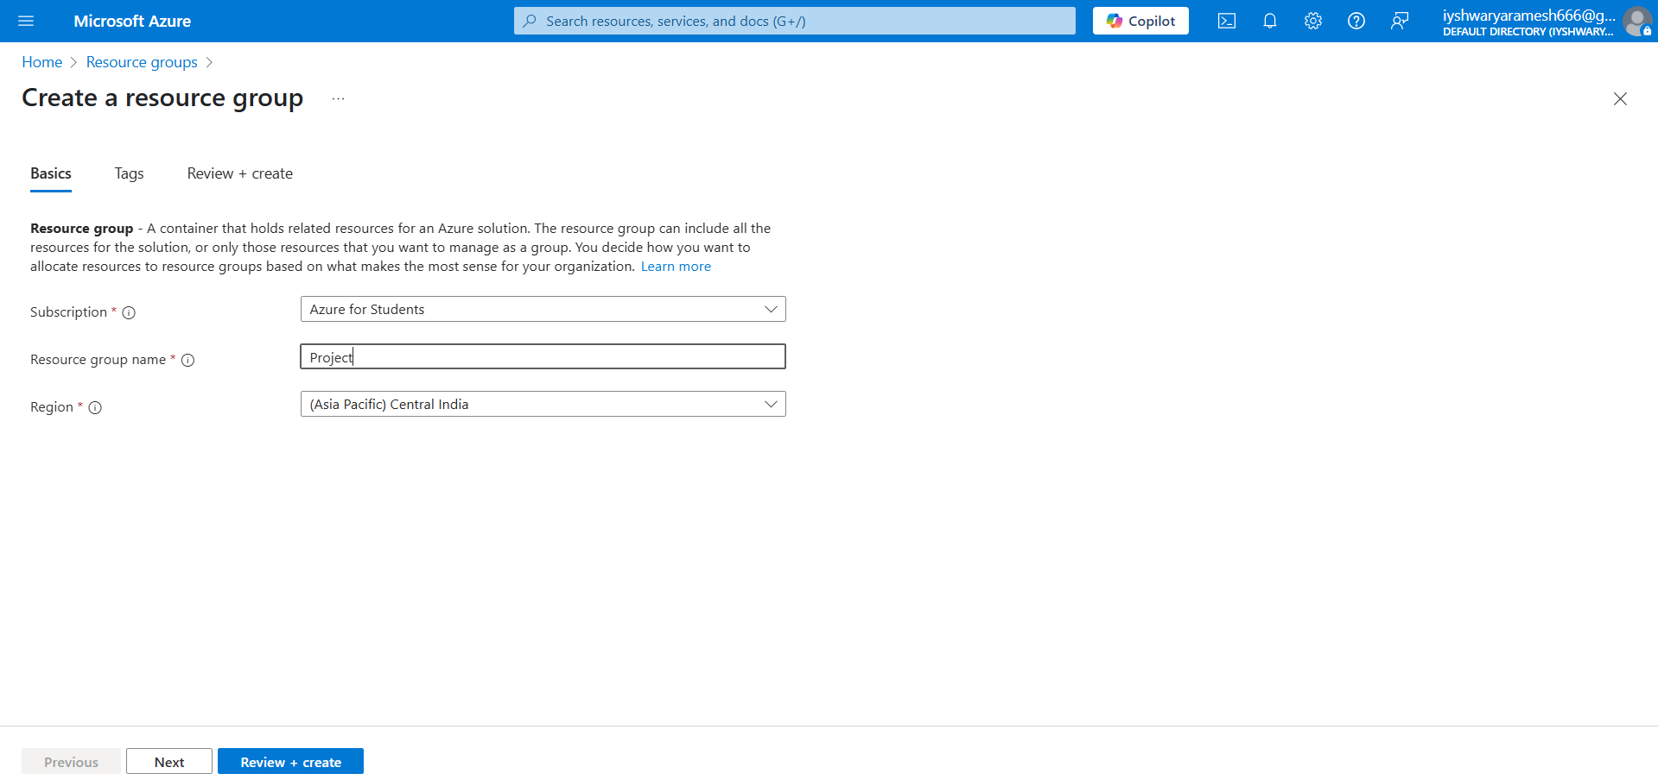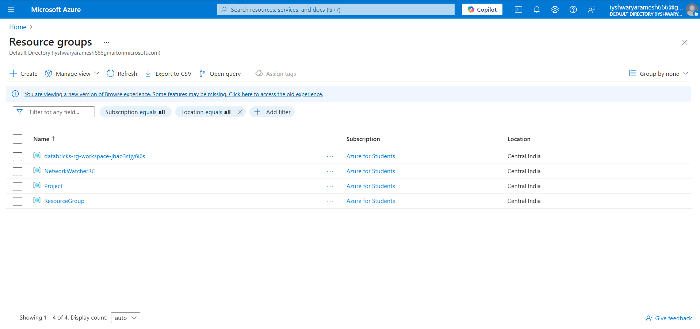

**CREATE A WORKSPACE**

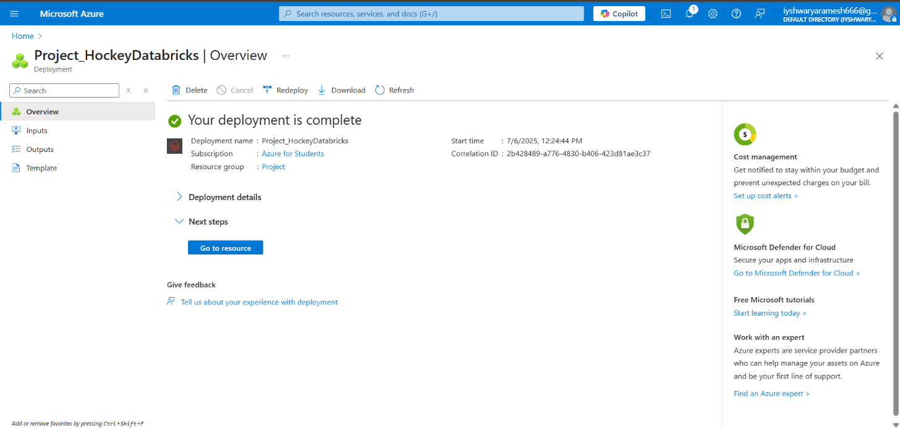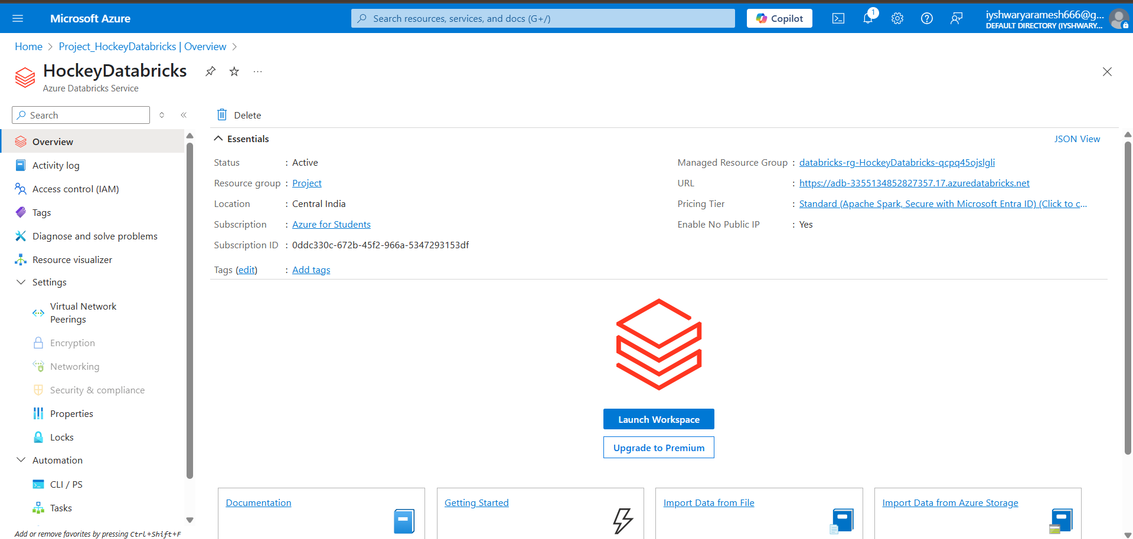

**CREATE TWO STORAGE ACCOUNTS**

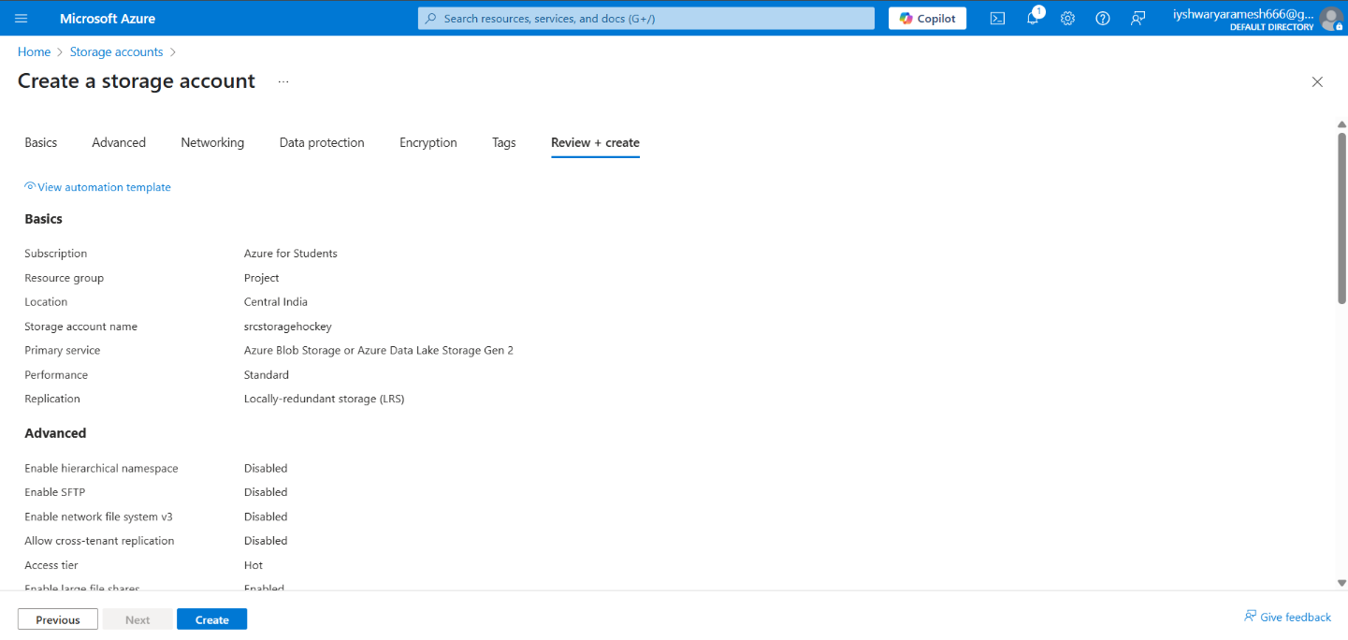

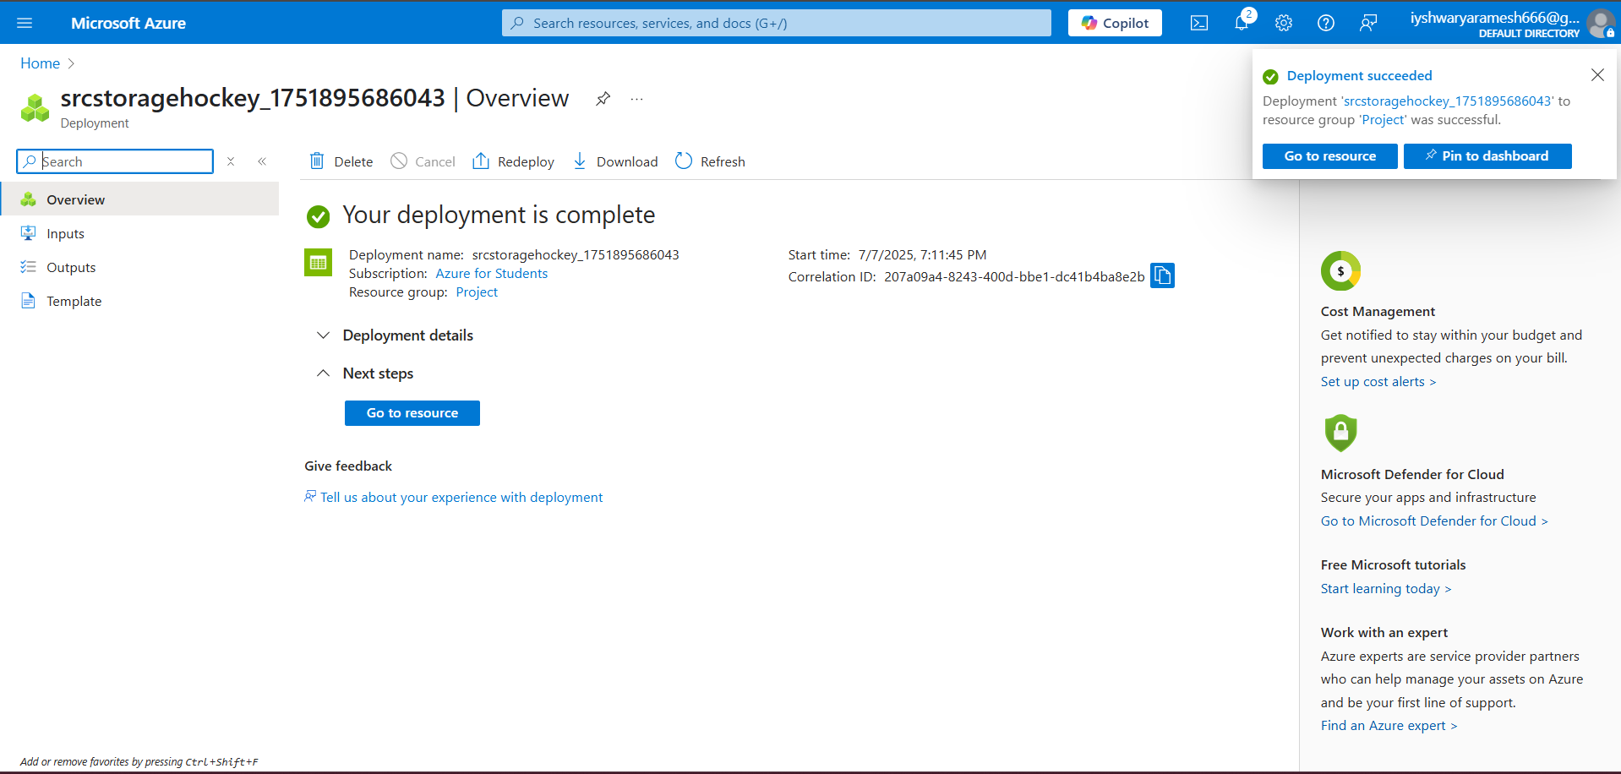

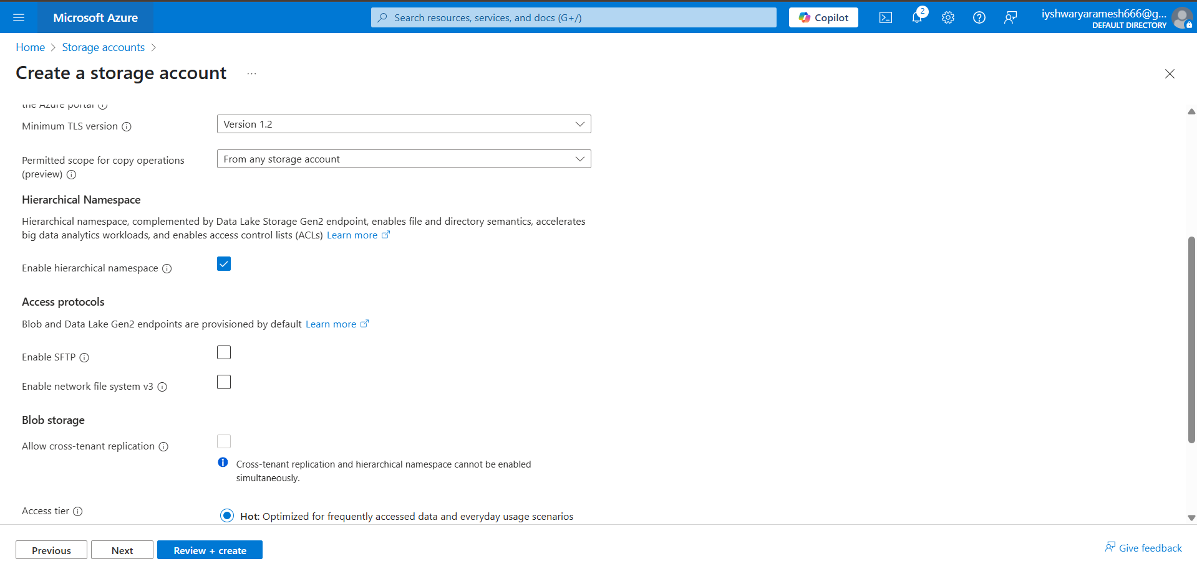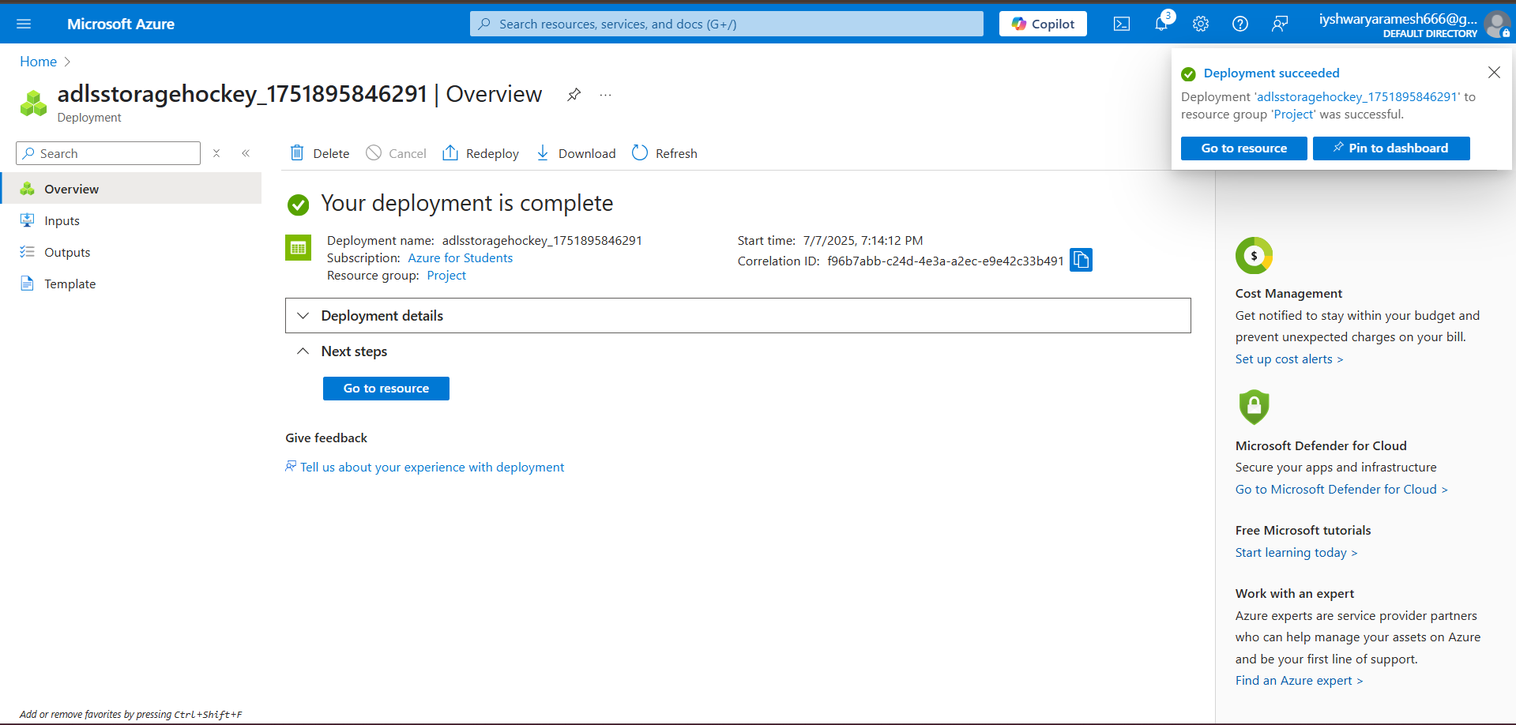

**CREATE CONTAINERS AND UPLOAD CSV FILES**

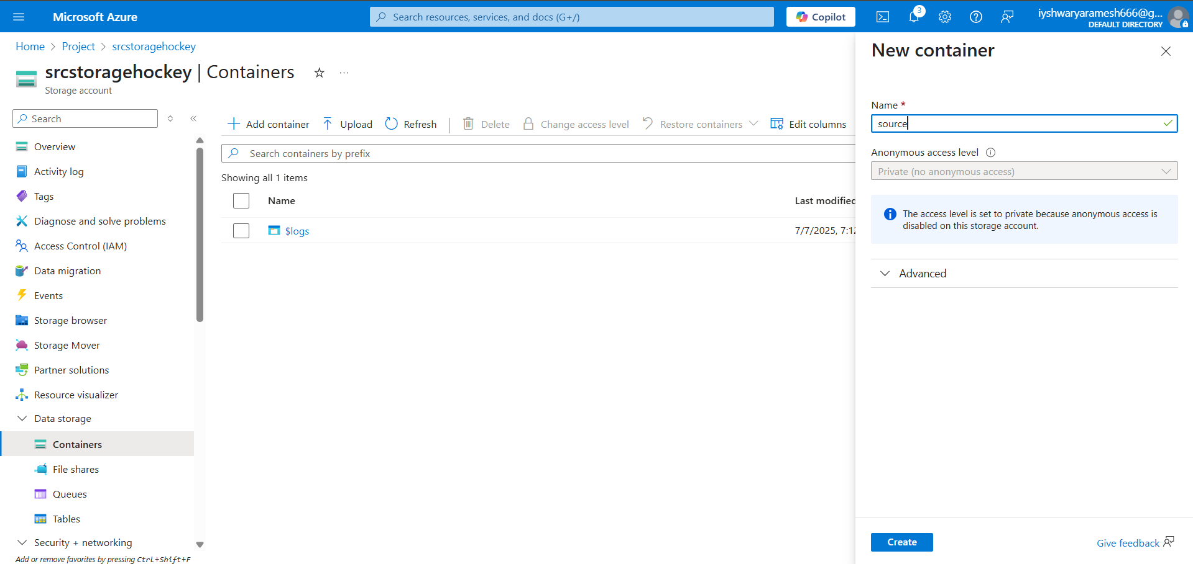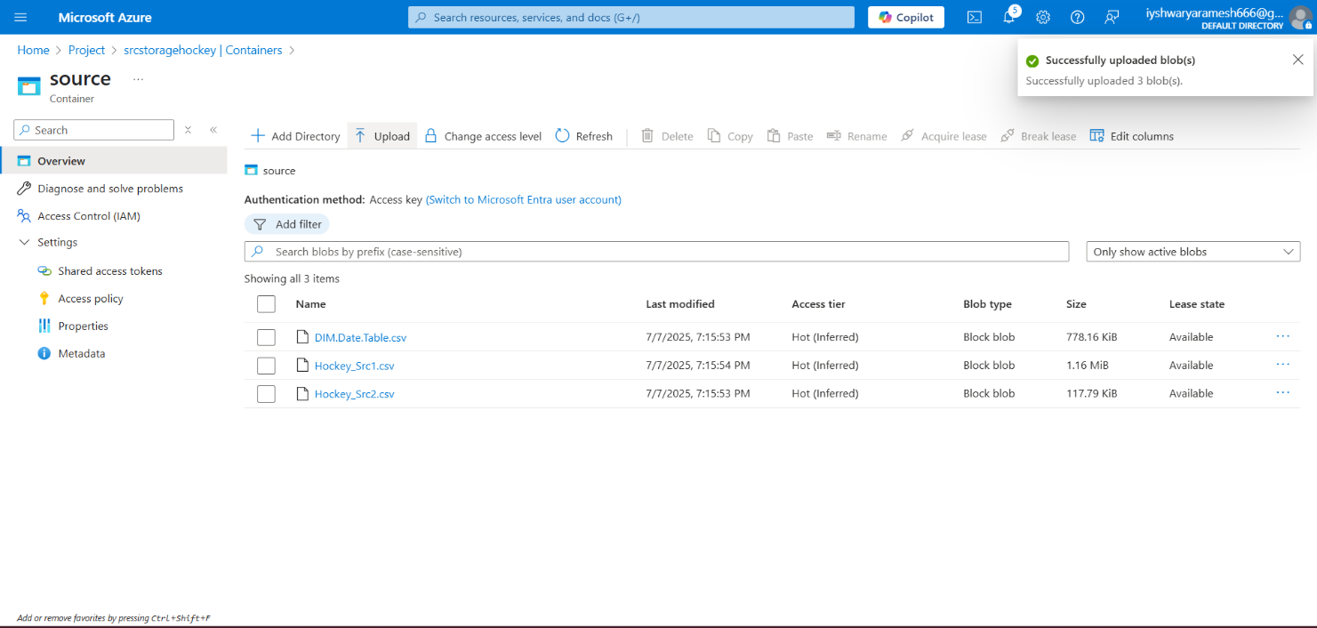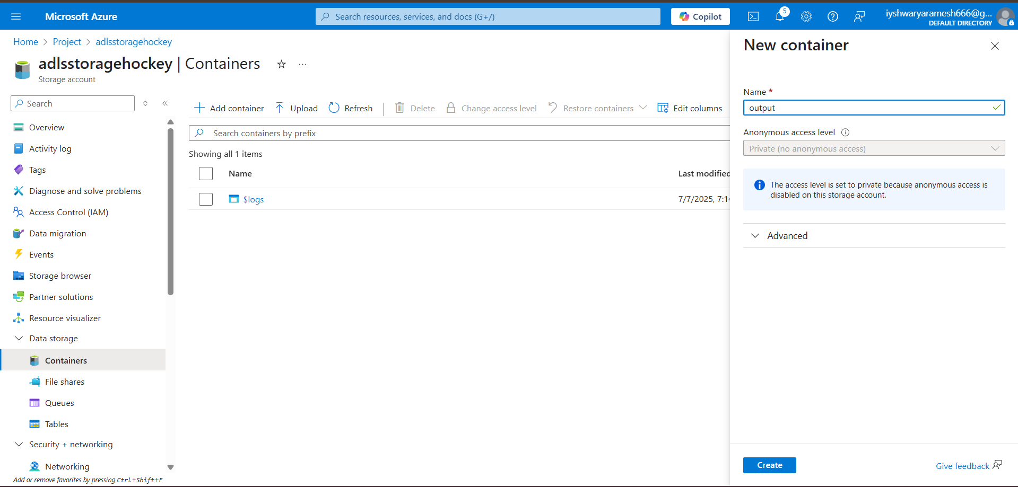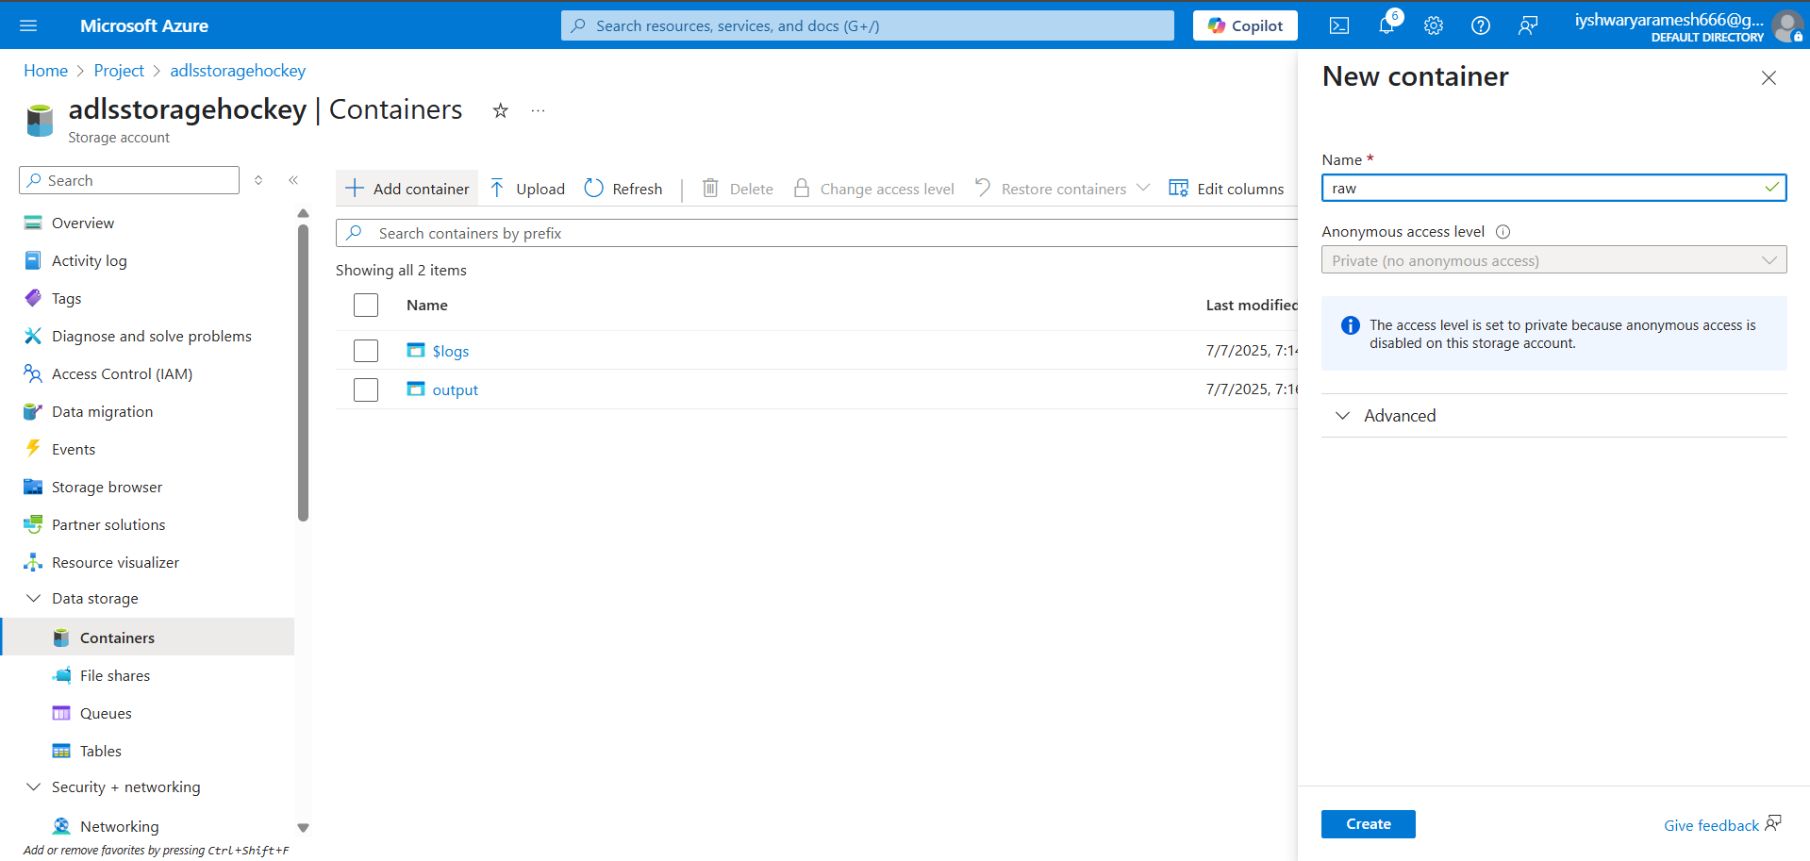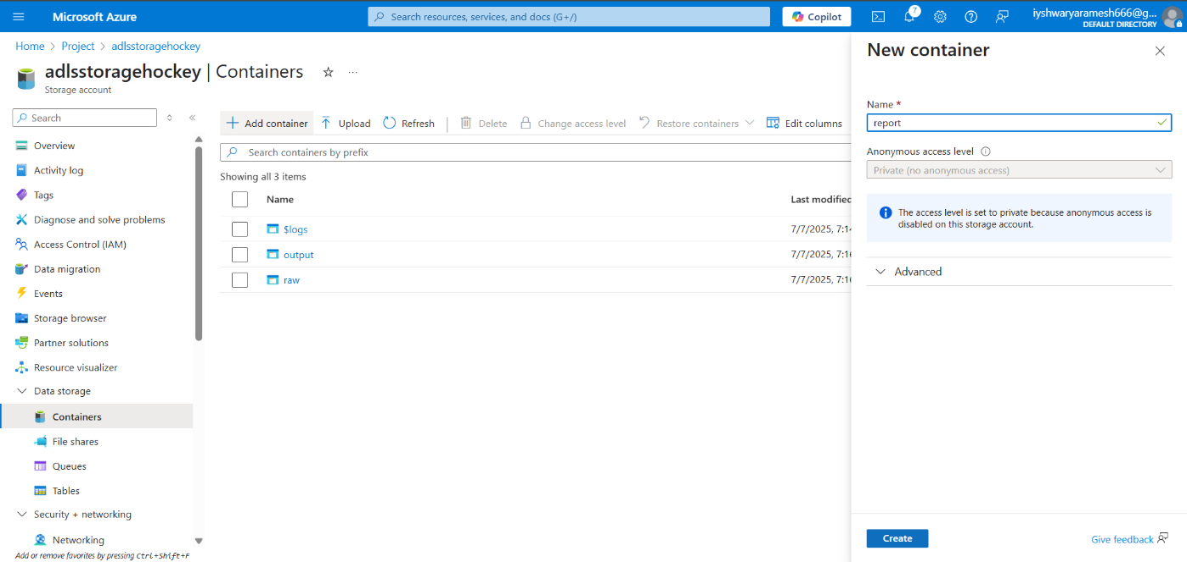

**PHASE 2: DATA FACTORY SETUP**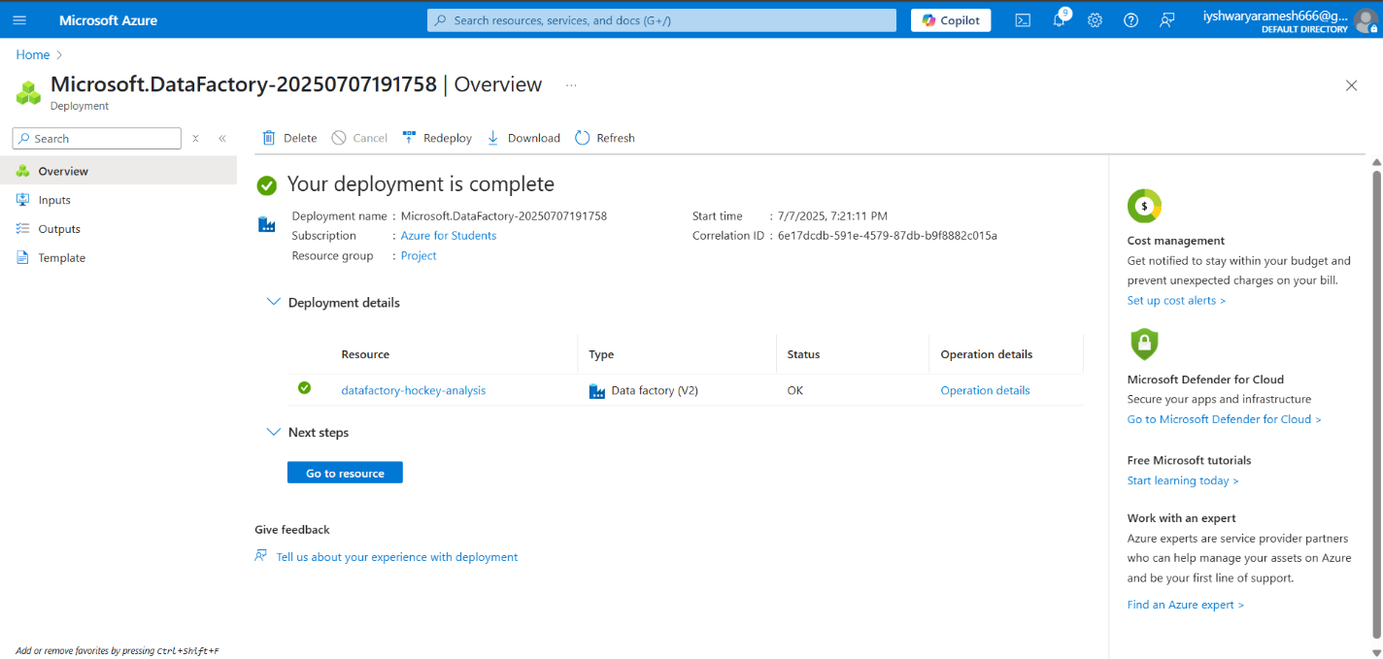

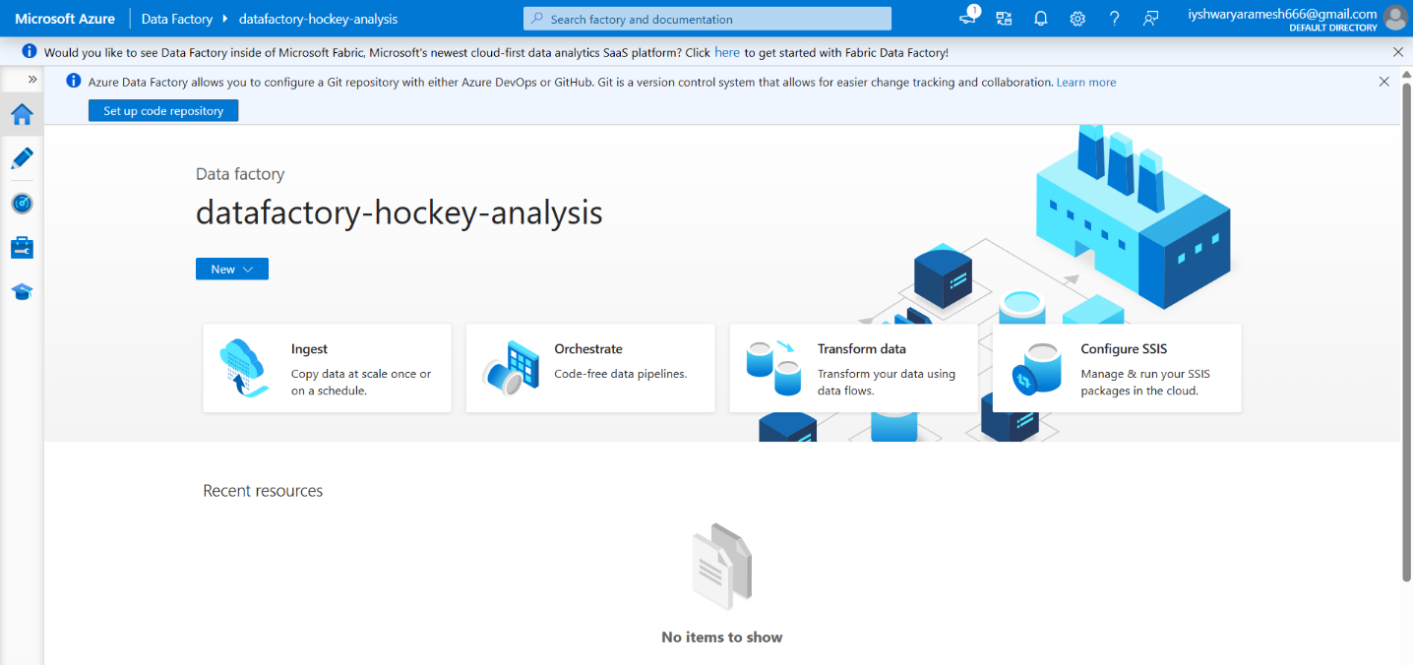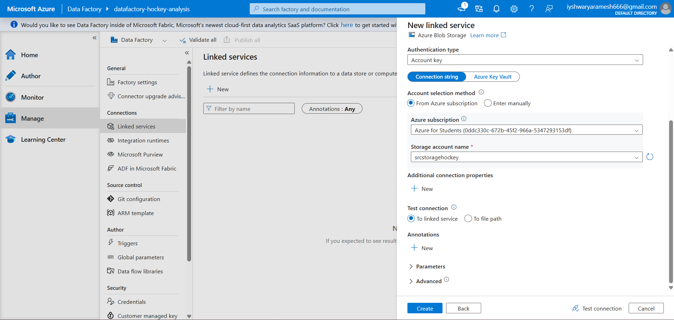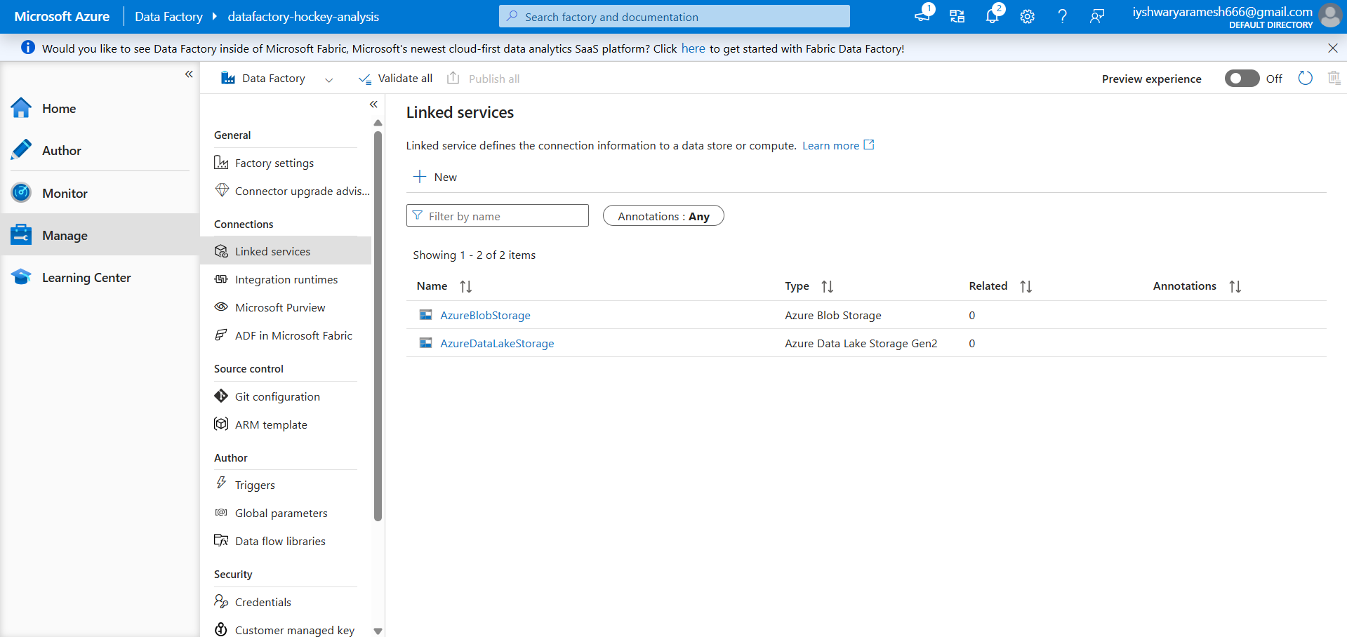

**SET DATASET AND PIPELINE:**

